18.6: The temperature is 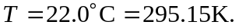 (a) The average molar mass of air is 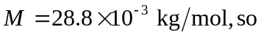
(b) For Helium 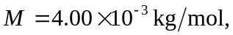so

